Blockchain Assignment 14
1. Write a smart contract to input and output a struct type with the following
details-
i. Struct Name- Car
ii. Struct parameters- Name, Engine, Model, Manufacturing year, total miles, mileage.

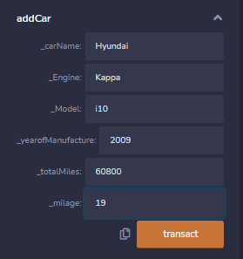

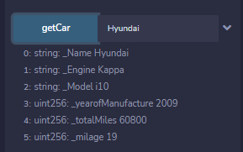

Empty input:

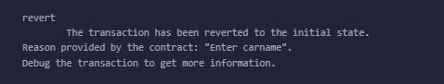

Code:
//SPDX-License-Identifier:MIT
pragma solidity ^0.8.0;

contract carStruct{

struct Car{
string Name;
string Engine;
string Model;
uint yearofManufacture;
uint totalMiles;
uint milage;
}

mapping(string => Car) carDetails;

function addCar(string memory _carName,string memory _Engine,string memory _Model,
uint _yearofManufacture, uint _totalMiles,uint _milage ) public {
Car memory cr;
cr.Name = _carName;
cr.Engine = _Engine;
cr.Model = _Model;
cr.yearofManufacture = _yearofManufacture;
cr.totalMiles = _totalMiles;
cr.milage = _milage;
carDetails[_carName] = cr ;
}

function getCar(string memory _carName) public view returns(string memory _Name,string memory _Engine,string memory _Model,
uint _yearofManufacture, uint _totalMiles,uint _milage)
{
if (bytes(_carName).length == 0)
{
revert("Enter carname");
}
//require(if (carDetails[_carName]),"Enter valid car details");

return (carDetails[_carName].Name,carDetails[_carName].Engine,carDetails[_carName].Model,
carDetails[_carName].yearofManufacture,carDetails[_carName].totalMiles,carDetails[_carName].milage);
}
}

